**Self Driving Cars:**

**Core Idea:**

A lot of very spefic tasks require machines and mechanisms to move from one place to another. Usually it is either manually moved by human power, or by a movement mechanism controlled by a human. Autonomous self driving vehicles can bypass this need and carry out tasks on their own.

Self Driving Vehicles use sensors , actuators (linear or angular) based in hydraulic and electric systems to do mechanical tasks. Machine learning and complex algorithms and a processing system is used to make judgement and make decisions.

**Components of an Autonomous Driving Vehicle:**

Sensors include a LIDAR and RADAR, both of them working simultaneously.

A compass and gyroscope can measure direction and orientation of the vehicle, and work in conjunction to the GPS system that navigates the vehicle to its destination

LiDaR stands for Light Detection and Ranging, It is able to take high resolution information of the surroundings, in adverse weather conditions. It uses different frequency of lights simultanouesly, and sends it to the processing system to overlay and create a better understanding of the surroundings.

Autonomous Steering Steering system is required to make sure the vehicle stays in its path and does not swerve uncontrollably. It also governs how to maneouver turns. Servos, steppers, or angular actuators can be used for such tasks.

**A brief moment when we talk about cars only.**

For example, In india, we have right hand drive and left side roads. Here maneouvering a right turn requires less servo activation for a larger arc. Left hand turns require more activation for a sharper turn

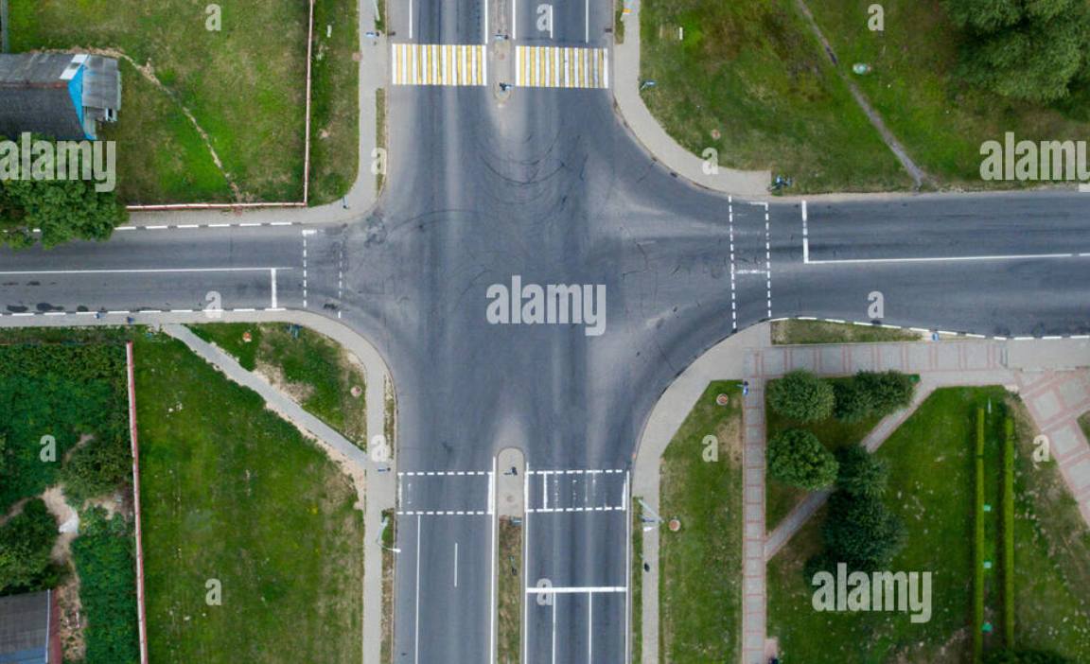

**Smaller arc**

**more steering**

**Larger arc**

**Less steering**



It also uses a complex algorithm to detect objects in the environment, if the object has an equivalent size and width to the car, and is moving, it is considered a car.

Thinner, slender tall objects are considered humans, after passing through a convulated neural network, the likes of which can be programmed in tensorflow.

There also needs to be a system for a driver or passenger to override and control the vehicle in case of emergency.

**Vision:**

The device needs camera at front and back for steering, and also on sides to make sure it maintains it lane and also leaves space for passengers when parking.

Three cameras at front and back, and one on each side should be enough to provide vehicle with enough input to run, although it may vary depending on price vs precision vs requirement.

To run it makes sure it isnt obstructed with an obstacle and while moving it makes contours of the lines on the road to stay in lane, the axle is only lightly turned on the opposite side, if a minor swerve occurs or the vehicle is losing its lane.

**Movement:**

A vehicle can either use a car like 4 vehicle axle mechanism

It can use a three wheel, one axle joining to wheels, and one wheel for steering. The axle may be in front like three wheel motorcycles, or at the back like in auto rickshaws

It can also eliminate the third wheel entirely, by using a rotating ball and socket, for maximum maneouverability.

Two wheel mechanism although possible are tougher to handle, because of the need to balance and are generally avoided, although plausible with a gyroscopic sensor and algorithms.

It will move with the data input from algorithm.

**Localisation:**

The vehicle can keep track of itself by taking sensor data, It can also map its motion and knowing the dimensions of its wheel mechanism, it can keep track of its position. In conjunction, it can dedicate static immovable objects like walls, through a neural network , but if such an object moves, it may lead to error in function.

Compass, and a GPS sensor is also able to keep track of the object, and an accelerometer to keep track if the surface the vehicle is on is itself moving.

**Architecture:**

The device will have image and video processing libraries, motor drivers.

Libraries to affect actuators and relay transistor circuits to supply power.

Motor driver circuits need to be created skillfull with a lot of variations and capacity to handle all kinds of situations.

**Conclusion:**

Automatic self driving vehicles are hard to make and set up, but the rewards they provide and the effort they save makes them worth the effort we put in.